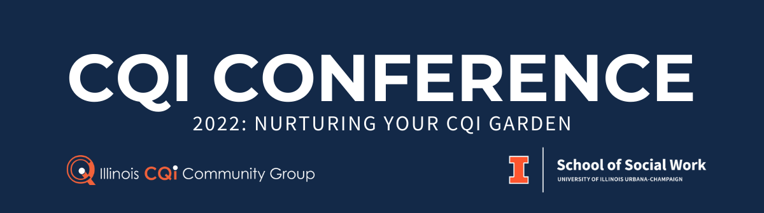
CONFERENCE REQUEST FOR PROPOSALS (RFP)
Deadline for Submission: May 6, 2022
Conference Dates: November 15 & 16, 2022
Location: Champaign, Illinois
Submit Proposal: CQICommunity@gmail.com

“Continuous quality improvement (CQI) is the complete process of identifying, describing, and analyzing strengths and problems and then testing, implementing, learning from, and revising solutions. It relies on an organizational culture that is proactive and supports continuous learning. CQI is firmly grounded in the overall mission, vision, and values of the agency. Perhaps most importantly, it is dependent upon the active inclusion and participation of staff at all levels of the agency, children, youth, families, and stakeholders throughout the process.” (“Using Continuous Quality Improvement to Improve Child Welfare Practice - A Framework for Implementation”, Casey Family Programs and the National Child Welfare Resource Center for Organizational Improvement, May 2005)

MISSION of the ILLINOIS CQI COMMUNITY GROUP
We are a community of human services professionals working to promote and enhance the value of CQI by providing opportunities for professional development, peer support, and collaboration.

PURPOSE OF THE CONFERENCE
The CQI Community Group’s annual conference is a capacity building and networking event. It is an opportunity for people from a variety of professional backgrounds to come together to explore strategies for developing, managing, and participating in CQI efforts that will lead to better outcomes for children, families and communities.

We invite you to submit a proposal for the 2022 CQI Community Conference “Nurturing Your CQI Garden”. This year’s conference will highlight innovative strategies for building, maintaining, and reaping the benefits of an effective 21st century CQI system. CQI systems in the 21st century should reflect an organization's policy, objectives and commitment to quality. This includes authentic engagement of the work force and service recipients throughout the CQI process, engaging in CQI activities that center race, equity and inclusion, and applying well developed quality tools and techniques throughout the organization.

WHAT WE ARE LOOKING FOR
We are seeking proposals for 75-minute workshops that feature innovative quality improvement strategies, methods, and tools that are practical, proven, or promising. Preference will be given to workshops that speak to the impact and/or practical application of the chosen topic and provide an opportunity for attendees to discuss how the information shared might be applied in their own settings. Providing attendees with concrete examples and opportunities for hands-on application is highly encouraged.

We are seeking presentations that provide relevant and actionable information that will enlighten human services professionals on a variety of quality improvement topics, including but not limited to the following:

Planting the Seeds for an Effective CQI System
- Ensuring equity and inclusion throughout the CQI system
- Fostering a culture of organizational learning
- Understanding the role of QA, CQI and evaluation
- Engaging external stakeholders and communities
- Building relationships and rapport between CQI and Program staff
- Writing CQI plans, procedures, and processes

Cultivating the System
- Choosing and using quality tools and techniques
- Developing performance measurement plans
- Applying different approaches to CQI such as PDSA, DMAIC, RBA, LEAN
- Building the capacity of CQI practitioners
- Assessing progress towards improvement
- Using technology for CQI
- Building data literacy
Harvesting & Sustaining the Rewards
- Telling the story about progress toward positive outcomes
- Building sustainability into the CQI process
- Sustaining positive gains
- Sharing results with constituents and communities
- Making evidence-driven decisions
- Using CQI to make a positive and equitable impact

The Illinois CQI Community group strives to promote diversity among workshop presenters and attendees in terms of professional affiliation (government, academic, or agency professional), agency size (small, medium, or large), and geography. We welcome proposals from those working in and outside of Illinois. Collaborative sessions representing multiple organizations are also encouraged.

Well-thought-out and well-designed workshops with concrete tools and solutions are sure to provide attendees with the best experience possible. Sessions with similar content or themes may be combined into panel presentations.

IMPORTANT DATES
- Proposals are due May 6th, 2022
- Proposals will be selected and presenters notified by end of June 2022
- Conference will be held in-person on November 15 & 16, 2022 at the IHotel in Champaign, Illinois

TARGET AUDIENCE
Our audience is primarily CQI staff, but also includes leadership and direct-service staff from community-based, academic, and government settings. This year's conference will be geared toward attendees with intermediate to advanced CQI knowledge and skills. Attendees seeking introductory/basic CQI knowledge will be encouraged to access the CQI Community Group’s “CQI 101: The How and Why of CQI” pre-conference webinar before attending the conference. The webinar can be accessed at: https://cqi.cfrc.illinois.edu/materials_meetings/CQI_MeetingMaterials_2021_09.pdf.

PROPOSAL CONTENT

PLEASE COMPLETE FULLY:
Primary Presenter (Individual with whom all communication will occur)
Name |  |  |  | Degree(s)
Pronouns
Position/Job Title
Organization
Address
City |  | State |  | Zip Code
Phone |  | E-mail

Co-Presenter
Name |  |  |  | Degree(s)
Pronouns
Position/Job Title
Organization
Address
City |  | State |  | Zip Code
Phone |  | E-mail

Co-Presenter
Name |  |  |  | Degree(s)
Pronouns
Position/Job Title
Organization
Address
City |  | State |  | Zip Code
Phone |  | E-mail

Speakers should be prepared to make presentation materials available electronically via the Illinois CQI Community website prior to the conference.
SESSION PROPOSAL CONTENT REQUIREMENTS

- Title of Session:

- Areas of focus (check all that apply):
☐ Planting the seeds for an effective CQI system
☐ Cultivating the system
☐ Harvesting and sustaining the rewards

- Briefly describe how your session meets the areas of focus.

- Workshop Goals and Objectives (100 words or less):

- Conference Workshop Description (150 words or less):
This will serve as the workshop description in the conference program.

- Describe how the workshop content can advance CQI in the human services sector. Describe any impact the workshop can or has had on CQI efforts, including a description of successes and/or lessons learned and any examples of practical application:

- Describe the plan for audience engagement and interaction throughout the session (beyond Q & A), include brief example(s):

- Describe any tools, techniques, and/or handouts that will be shared:

- Applicable Areas within Human Services (choose all that apply):
☐ Child Welfare
☐ Community Services
☐ Early Childhood
☐ Education
☐ Government
☐ Health
☐ Juvenile Justice/Community Corrections
☐ Mental Health
☐ Older Adult
☐ Public Health
☐ Youth Services
☐ Multi Service Organizations
☐ Other: __________________________________

SUBMISSION OF RFP
TO BE CONSIDERED, ALL THE MATERIALS BELOW MUST BE SUBMITTED:
- Biography for each presenter (150 words or less)
- Resume for each presenter
- Completed (RFP) (proposal content and session proposal content requirements)
- Handouts
- Draft slides and/or presentation outline
- High Resolution Headshot (3"x4" at 300dpi., jpg file)
Website resource to convert to high resolution photos:
https://www.techwalla.com/articles/how-to-convert-pictures-to-high-resolution-jpeg

Submit questions to: CQICommunity@gmail.com

