**Communication Style Survey**

* On each line, read the 4 choices, & select/circle the word or phrase that is most descriptive of you. There is no such thing as a ‘best’ style, so do not choose what sounds ‘best.’ **Do not over-think. Choose which most describes you on each line.**
* Then, count how many you have in each row.

|  |  |  |  |  |
| --- | --- | --- | --- | --- |
|  | **Row 1** | **Row 2** | **Row 3** | **Row 4** |
| 1. | Like to analyze | Like to interact | Like to decide | Like to explore |
| 2. | Objective | Emotional | Practical | Visionary |
| 3. | Logical | Encouraging | To the Point | Creative |
| 4. | Consistency | Spontaneity | Determination | Insight |
| 5. | Order | Cooperation | Results | Concepts |
| 6. | Value details | Bored with details | Value facts | Value ideas |
| 7. | Controlled | Personable | Action-oriented | Dreamer |
| 8. | Composed | Empathetic | Quick | Intellectual |
| 9. | Cautious | Enthusiastic | Sensible | Original |
| 10. | Formal | Informal | Motivating | Inspiring |
| 11. | Detached | Sentimental | Impatient | Preoccupied |
| 12. | Problem-solver | Supporter | Implementer | Developer |
| 13. | Data | Feelings | Plain talk | Possibilities |
| 14. | Critical | Moody | Driven | Distant |
| 15. | Truth | Harmony | Reality | Change |
| 16. | Precise | Tactful | Direct | Complex |
| 17. | Value accurate time tables | Value past life events | Value present events | Value future achievements |
|  | **Row 1 Count:** | **Row 2 Count:** | **Row 3 Count:** | **Row 4 Count:** |

**Interpreting your Communication Style Score**

Everyone has their own major and minor communication style they can use in their work and personal life based upon four primary communication styles. There are behavior patterns associated with each style. See table below. And, many of us tend to lean into different communication styles under stress.

|  |  |
| --- | --- |
| **Style** | **Details** |
| **Row 1: Thinker,** Computing, Goals Driven | Analyzing, ordering in logical fashion |
| **Row 2: Feeler,** Connecting, People Driven | Relating to & understanding experience through emotional reactions & response to feelings |
| **Row 3: Sensor,** Commanding, Results Driven | Experiencing mainly based on personal sensory perceptions; ’just do it’ style |
| **Row 4: Intuitor,** Creating  Vision Driven | Conceiving, projecting, inducing |

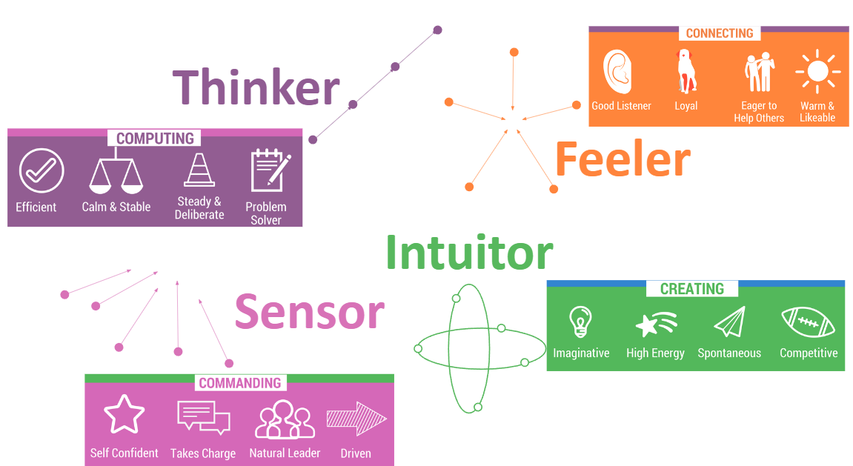

***Vision Driven***

***Results Driven***

***People Driven***

***Goals Driven***

**Characteristics of the 4 Communication Styles**

|  |  |  |
| --- | --- | --- |
|  | **Strengths** | **Challenges** |
| ***Thinkers*** | * Good at putting things in order * Talent for analyzing problems/situations * Make objective decisions based on logic * Tend to be brief and businesslike * Value accuracy and preciseness * Treat people fairly * Follow policies and rules * Sought out for problem solving abilities | * Can be overly cautious or too slow * Might miss the forest for the trees * Can hurt other’s feelings * Might not give enough positive feedback * Knack for remembering policy, adhering to policy & attention to detail can cause a Feeler to think the Thinker is looking for things to criticize |
| ***Feelers*** | * Are good at building rapport and communicating tactfully * Consider the impact on other people when making decisions * Have a talent for empathizing and creating harmony * Are naturally friendly and have a good sense of humor * Take an interest in the person behind job * Treat each person uniquely | * Overly personalize situations * Relationships can cloud judgment * Might overlook important details * Lack of planning can cause disorganization * May spend too much time socializing * Ask a feeler “how are you” & they tell you more than you ever wanted to know. |
| ***Sensors*** | * Are resourceful, determined, practical and down-to-earth * Have a talent for getting things done * Make decisions quickly based on facts and past experience * Focus on actions, results and rewards * Like to get to the “bottom line” or “cut to the chase” * Enjoy the present moment * Work steadily with a realistic idea of how long it will take. | * Impulsive * Competitive * Aggressive * Impatient * Disregard long-term consequences of actions/decisions * Under stress may alienate others * May be poor listeners often interrupt * Might create ‘messes’ for others to ‘clean up” |
| ***Intuitors*** | * Are visionary, seem to see into the future and are good, long-range planners * Love to learn new skills * Have great imaginations * Focus on how things can be improved * Are able to identify creative solutions and fresh and novel approaches | * Absent-minded” scattered * Long on vision, short on action * Avoid nitty-gritty, hates phone coverage * Hard to read * May come across as ‘superior’, arrogant, or condescending * May not follow-through on tasks * May procrastinate |