**CQI Community Mentor Application**

**Thank you for your interest in participating in our continuous quality improvement (CQI) professional mentorship program. During this 6-month program, mentor/mentee pairs will build a mutually beneficial relationship that will strengthen skillsets and support career growth. Please note that based on mentee applications and interests, not everyone who applies may be matched with a mentee.**

**There will be a required mentorship kick off meeting on March 20, 2025 and the program will run from April through September. Mentor/mentee pairs are expected to meet at least monthly over the course of the program. There will also be two mentor-only group check-ins (May 20th and August 26th) and an all-cohort session on July 10th during the program.**

**Applications are due by December 31, 2024 online:** [**https://www.surveymonkey.com/r/CQIMentorApplication**](https://www.surveymonkey.com/r/CQIMentorApplication)

**BACKGROUND INFORMATION**

**Name:**

**Preferred Pronouns:**

**Agency/Organization:**

**Agency/Organization Address:**

**Job Title:**

**Essential Job Functions:**

**E-mail:**

**Phone Number:**

**Number of years in the workforce:**

**Number of years working in quality improvement:**

**\*Please upload a current resume.**

**Please share a current bio:**

**Educational Background: Include the specific degree(s) below:**

* Bachelor’s degree(s):
* Master’s degree(s) and area(s) of concentrations:
* Doctoral degree(s):
* Other degrees or certifications:

**What is the structure of quality improvement at your organization? (e.g., separate department, embedded within the program, team, single person)**

**Size of organization:**

* Very Small (Under $1M)
* Small ($2-5M)
* Medium ($5-10M)
* Large ($10-25M)
* Very Large (>$25M)

**Type of Organization:**

* Human Service Agency
* Government Agency/Department
* Healthcare
* University/College
* Other (please specify)

**Region served:**

* Local
* Statewide
* Multi-state
* Other (please specify)

**Where do you fit within quality improvement at your organization? (e.g., part of the quality improvement department, program team, adjacent)?**

**PRIOR MENTORSHIP EXPERIENCE**

**Have you participated in a formal mentoring program before? Yes/No**

**What mentorship program(s) have you participated in?**

**Which program(s) were you a:**

*Mentor:*

*Mentee:*

**How was your experience being a mentor/mentee?**

**MENTORSHIP GEOGRAPHIC PREFERENCES**

**The CQI Community draws participants from across the United States. Are there any geographic limitations that we should factor into your mentee match (e.g., do you prefer to have a mentee within driving distance, in state, virtual only, etc.)**

**If you reside in a different state than where your organization is located, please specify below.**

**PROFESSIONAL AND QUALITY IMPROVEMENT STRENGTHS**

**Continuous Quality Improvement Areas of Expertise**

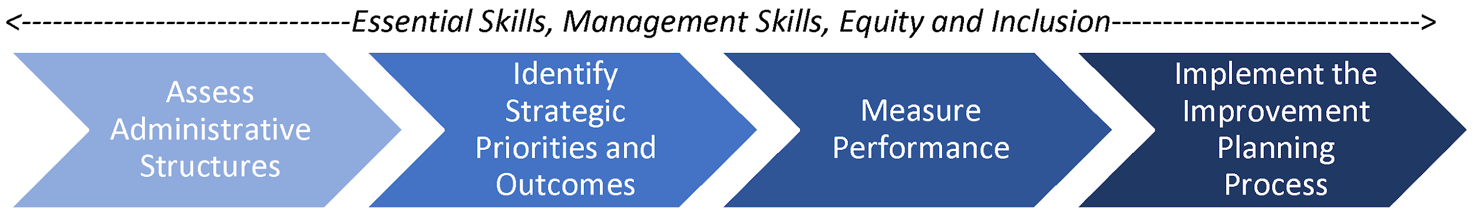

**Please select your quality improvement area(s) of strengths and give a brief overview of your experience in these area(s) (select all that apply):**

☐ **Professional Skills** (e.g., building relationships and buy-in to quality improvement, working with teams, facilitating difficult discussions, conflict resolution)

☐ **Management Skills** (e.g., supervising/managing people, managing projects and processes, training)

☐ **Equity and Inclusion** (e.g., engaging stakeholders and communities, identifying and addressing disparities, creating inclusive measurement tools)

☐ **Assess Administrative Structures** (e.g., IT or database systems, CQI policies & planning, infrastructure, quality improvement teaming)

☐ **Identify Strategic Priorities and Outcomes** (e.g., develop theories of change, develop logic models)

☐ **Measure Performance** (e.g., performance improvement/measurement/evaluation planning, surveys and other data collection tools, data analysis methods, data reporting , dashboards and other data visualizations)

☐ **Implement the Improvement Planning Process** (e.g., PDSA, LEAN Six Sigma, Results Based Accountability, improvement cycles)

☐ **Accreditation** (e.g., COA (Council on Accreditation), CARF (Commission on Accreditation of Rehabilitation Facilities), Joint Commission)

☐ **Other**

**Why do you want to be a mentor?**

**What are you specifically hoping to offer a mentee?**

**What characteristics would be most important to you for a strong mentee match?**

**Is there any further information that you feel would be valuable to know about you which may aid in the matching process?**

**Thank you for your application. We will be in touch soon.**