
CQI Community Mentor Application

Thank you for your interest in participating in our continuous quality improvement (CQI) professional mentorship program. During this 6-month program, mentor/mentee pairs will build a mutually beneficial relationship that will strengthen skillsets and support career growth. Please note that based on mentee applications and interests, not everyone who applies may be matched with a mentee.

There will be a required mentorship kick off meeting in March of 2026 and the program will run from April through September. Mentor/mentee pairs are expected to meet at least monthly over the course of the program. There will also be two mentor-only group check-ins in May and August in July during the program.

Applications are due by December 31, 2025 online: https://www.surveymonkey.com/r/CQIMentorApplication

BACKGROUND INFORMATION
Name:

Preferred Pronouns:

Agency/Organization:

Agency/Organization Address:

Job Title:

Essential Job Functions:

E-mail:

Phone Number:

Number of years in the workforce:

Number of years working in quality improvement:

*Please upload a current resume.

Please share a current bio: (Note: This will be shared on the website and included on the mentee application as their rank their interest and preferences in working with mentors)
Educational Background: Include the specific degree(s) below:
- Bachelor’s degree(s):
- Master’s degree(s) and area(s) of concentrations:
- Doctoral degree(s):
- Other degrees or certifications:

What is the structure of quality improvement at your organization? (e.g., separate department, embedded within the program, team, single person)

Size of organization:
- Very Small (Under $1M)
- Small ($2-5M)
- Medium ($5-10M)
- Large ($10-25M)
- Very Large (>$25M)

Type of Organization:
- Human Service Agency
- Government Agency/Department
- Healthcare
- University/College
- Other (please specify)

Region served:
- Local
- Regions
- Statewide
- Multi-state
- Other (please specify)

Where do you fit within quality improvement at your organization? (e.g., part of the quality improvement department, program team, adjacent)?

PRIOR MENTORSHIP EXPERIENCE
Have you participated in a formal mentoring program before? Yes/No

What mentorship program(s) have you participated in?

Which program(s) were you a:
Mentor:
Mentee:

How was your experience being a mentor/mentee?

MENTORSHIP PREFERENCES
The CQI Community draws participants from across the United States. Are there any geographic limitations that we should factor into your mentee match (e.g., do you prefer to have a mentee within driving distance, in state, virtual only, etc.)

If you reside in a different state than where your organization is located, please specify below.

How many mentees are you open to mentoring for this upcoming cohort? (Please note that these would be separate 1:1 mentorship relationships and not group mentoring)
- 1 mentee only
- 2 mentees

PROFESSIONAL AND QUALITY IMPROVEMENT STRENGTHS
Continuous Quality Improvement Areas of Expertise
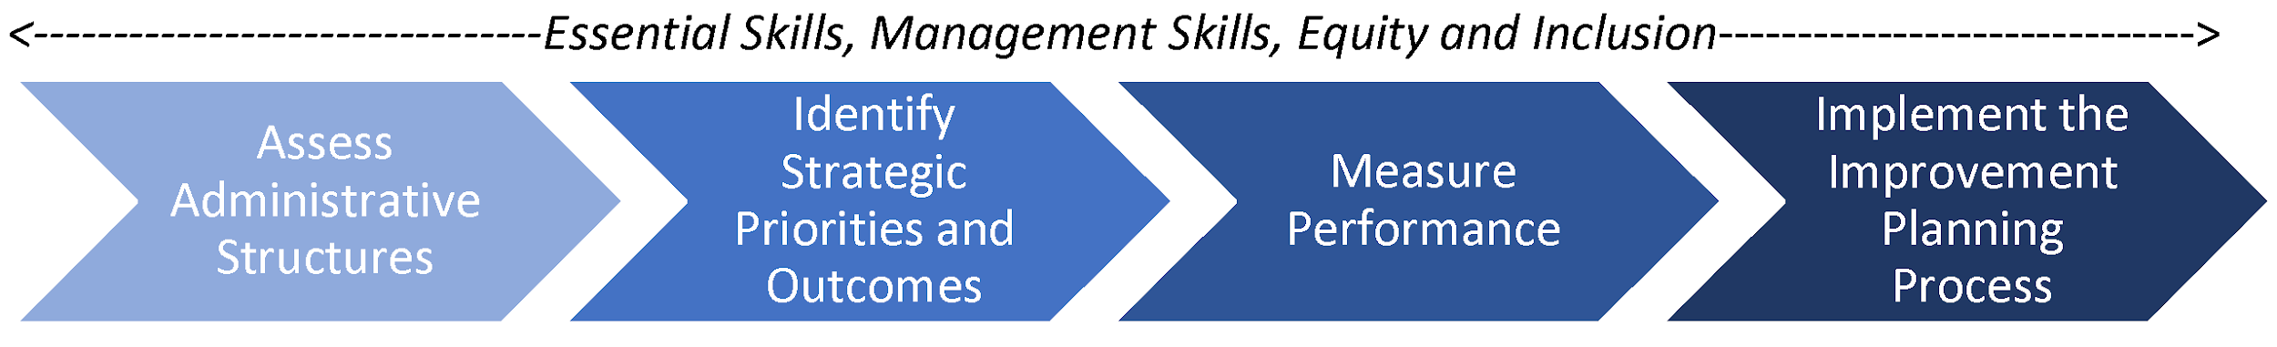
Please select your quality improvement area(s) of strengths and give a brief overview of your experience in these area(s) (select all that apply):

☐ Professional Skills (e.g., building relationships and buy-in to quality improvement, working with teams, facilitating difficult discussions, conflict resolution)

☐ Management Skills (e.g., supervising/managing people, managing projects and processes, training)

☐ Equity and Inclusion (e.g., engaging stakeholders and communities, identifying and addressing disparities, creating inclusive measurement tools)

☐ Assess Administrative Structures (e.g., IT or database systems, CQI policies & planning, infrastructure, quality improvement teaming)

☐ Identify Strategic Priorities and Outcomes (e.g., develop theories of change, develop logic models)

☐ Measure Performance (e.g., performance improvement/measurement/evaluation planning, surveys and other data collection tools, data analysis methods, data reporting , dashboards and other data visualizations)

☐ Implement the Improvement Planning Process (e.g., PDSA, LEAN Six Sigma, Results Based Accountability, improvement cycles)

☐ Accreditation (e.g., COA (Council on Accreditation), CARF (Commission on Accreditation of Rehabilitation Facilities), Joint Commission)

☐ Other

Why do you want to be a mentor?

What are you specifically hoping to offer a mentee?

What characteristics would be most important to you for a strong mentee match?

Is there any further information that you feel would be valuable to know about you which may aid in the matching process?

Thank you for your application. We will be in touch soon.

